/How to Turn Any Board Game into a Learning Game
Board games can be educational by themselves. Games are universal learning tools! They are effective for all ages, and cultures because they turn learning into entertainment. And there’s no need to spend extra money on learning games for your kids when you probably have a ginormous game closet already! Simply use a little creativity to alter the game and turn math, reading, and writing into an experience your children will never forget.
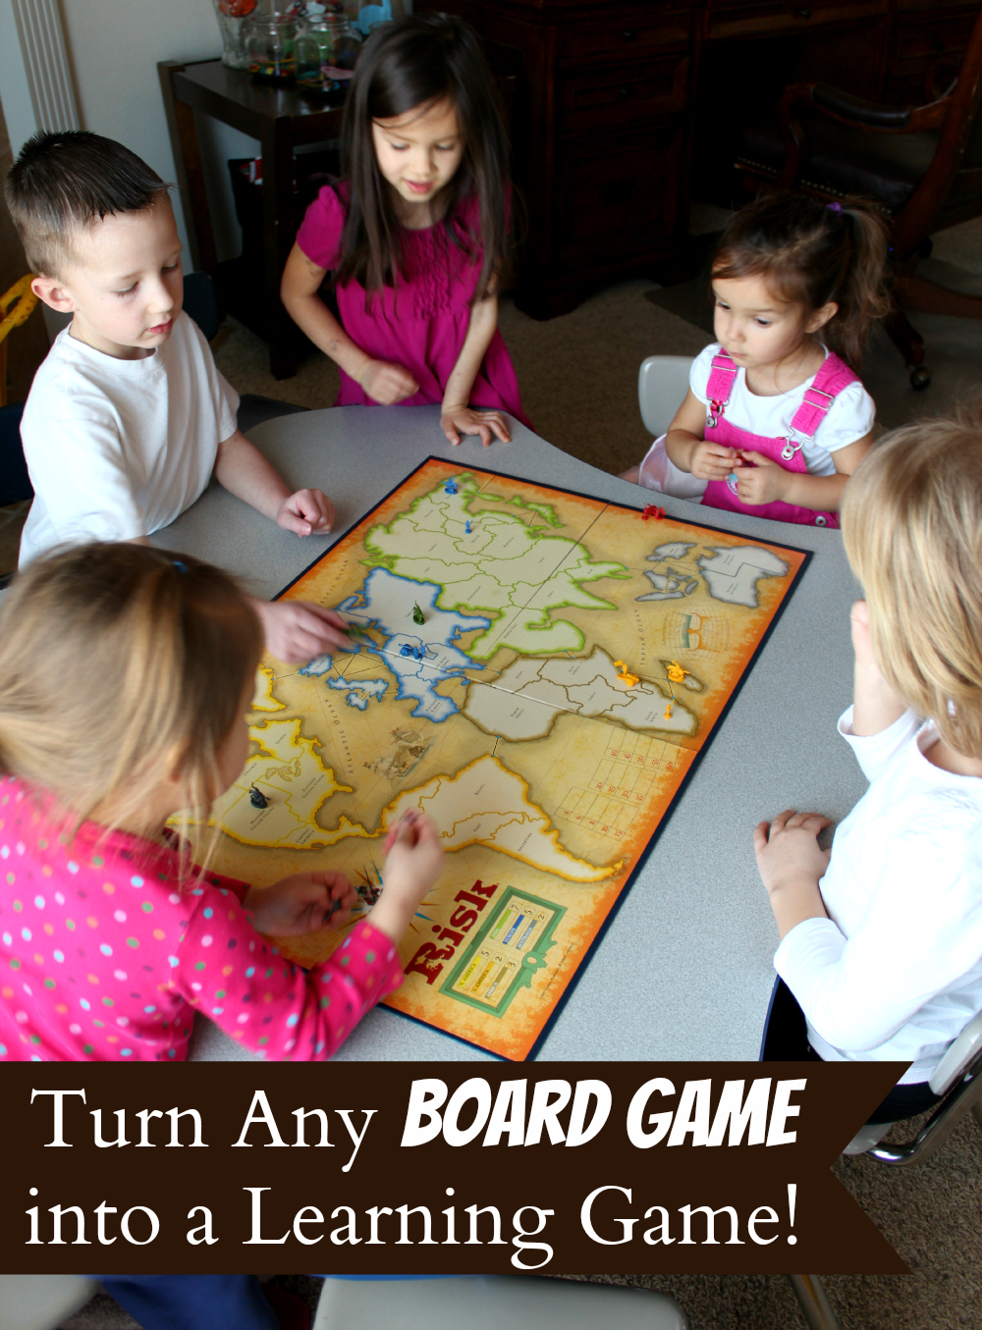

Here are some of the games we altered and played:

Risk
1. Find your man. Pass out 5-7 soldiers (or use small toys) to your children and have them place 1 soldier in a country space. Tell them that their men are lost and they must complete all the missions to save all of them. Have them read a flash card (missions), numbers or letters, to be able to retrieve one man. There can be multiple winners in this game or you can make it a cooperative game and have everyone help save the soldiers.
2. Conquerors. Play the same way as above except, instead of saving the soldiers, you can take another player’s soldiers away.
3. Country Find. Use the risk country cards to play a matching game. Pass out the cards to your children and see how fast they can match their soldiers with their country card.

Monopoly
1. Counting skills. Use the original rules minus the money. Roll the dice, count the dots and move your piece, seeing who can collect the most properties. If you land on the property first you get it!
2. Sight Word Practice. Again, play without using money. Place flashcards on all of the spaces and see who can read the most!
3. Matching Game. Deal some of the property cards to your children and see who can match their cards to the right properties on the board first.

Candy Land
This game isn’t an adult game, but my kids love it! I, on the other hand, would throw it out if I didn’t see a post about using it to practice sight words. The Blogger has some special cards you can buy, and I did! But then I realized that I didn’t need the special cards and could use the flash cards I already have and the color cards that already come in the game. Face palm!
1. Secret Pass Word. Simply tell your children that in order to get a color card and move their piece they have to figure out what the secret pass word is. The beauty of doing it this way is that you can use any kind of flash cards or even just ask them questions to make it a math, history, even a geography game!
2. Memory Game. You can use the color cards to play a simple memory game.

